Experiencing SCRUM|Lego City

Team Name: Neo | EBAC4|K.E.29 |

[Anusuya Manickavasagam: A0163300Y,

Lydia: A0163289U,

Muni: A0163382E,

Pradeep: A0163453]

Contents

Business Objectives 2

Project Deliverables 2

Initial Technical Strategy/Analytical/Modeling Approach 3

System Diagram 3

Data Gathering 4

Project Planning 5

Project Methodologies 6

Source Code Management 6

Project Tasks Management 6

Roles and Responsibilities 7

Resources Requirement 7

Project Deliverables and Plan (Gantt Chart) 8

Current Problems and Risks 8

Initial Analysis and Modeling 9

References 11

# Objectives

This assignment is part of CA3 to share the experiences and results for our Lego City project. The principle objective was to experience SCRUM methodology and build the project from scratch.

# Team Agreements

Before starting as a team, it is very important to have team agreements. We have come up with following agreements. Based on the work experience, we agree to edit them on the go:

* Respect every member’s time
* Be attentive in the discussions
* No usage of Mobile phones during the discussions
* Standup in every class
* Full attendance

# High Level Process

At a very high level we followed the process as below. We will explain each phase in detail:

# Requirement Brainstorm

As a team we wore the Product owner hat and decided upon all the features possible for a **Lego City project.** Once we identified the features in terms of **user stories,** we estimated them wearing developers hat. The process was to pick a smallest one and then size other against it. Below image shows the work done to make user stories and size them:

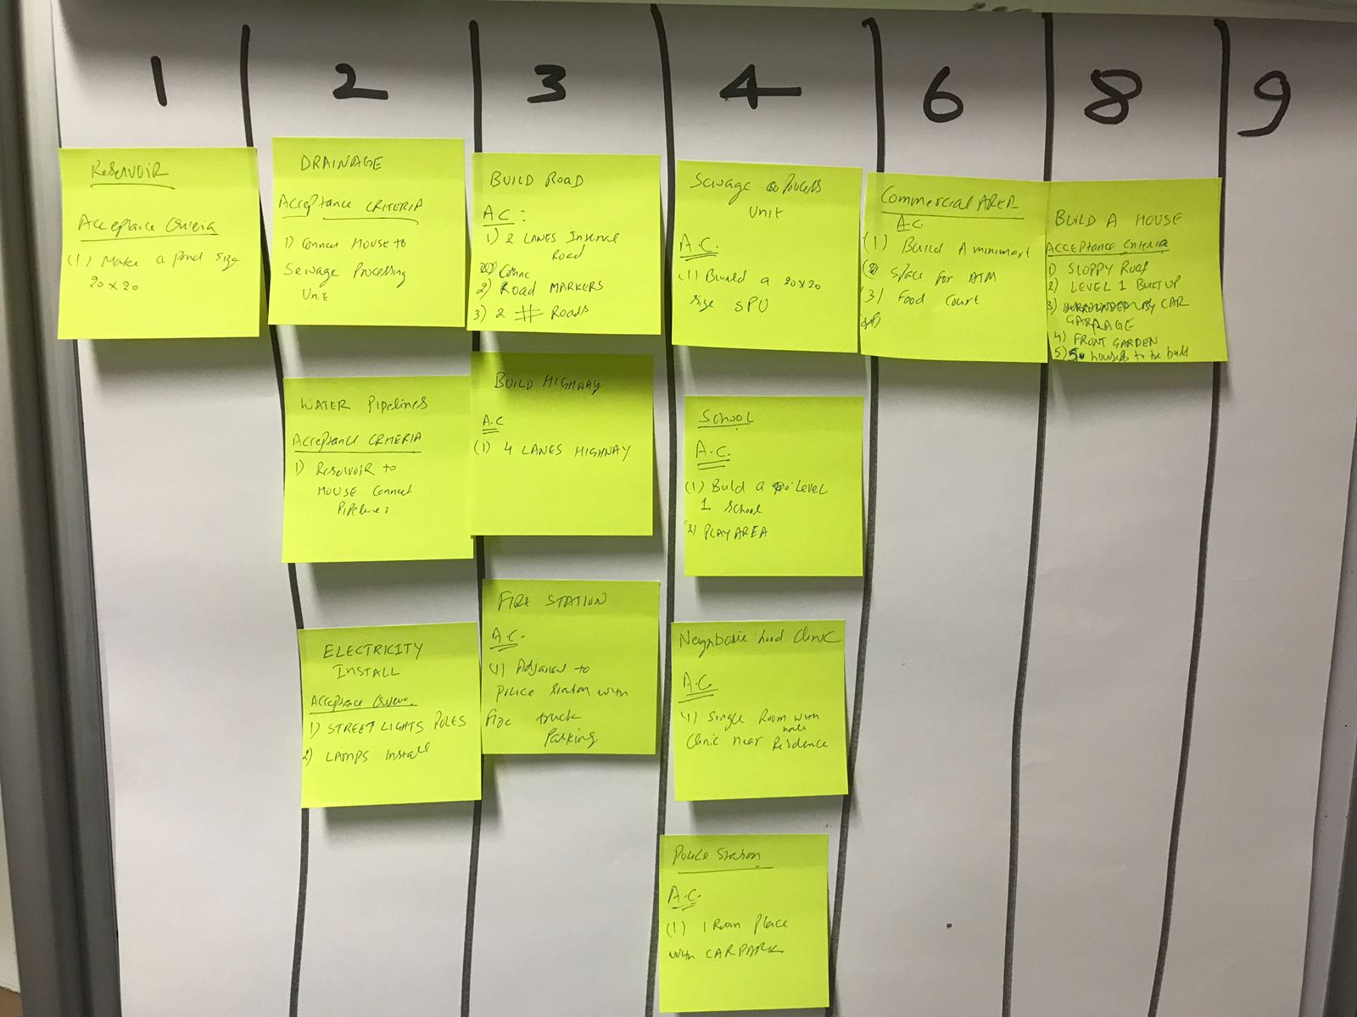

# Sprint Planning

Next, we entered in the Sprint planning mode. Since we had 2 sprints, we scoped out few user stories and accordingly planned for high priority stories. Accordingly, we pulled the stories in the First Sprint and prepared the task with minutes estimates:

## First Sprint Planned:

1. Build Road
2. Build Water Pipeline
3. Build 4 houses

## First Sprint Execution:

We could not achieve the target on Day 1 of the Sprint but by the Day 3 end we could finish the expected stories planned for the Sprint as shown below:

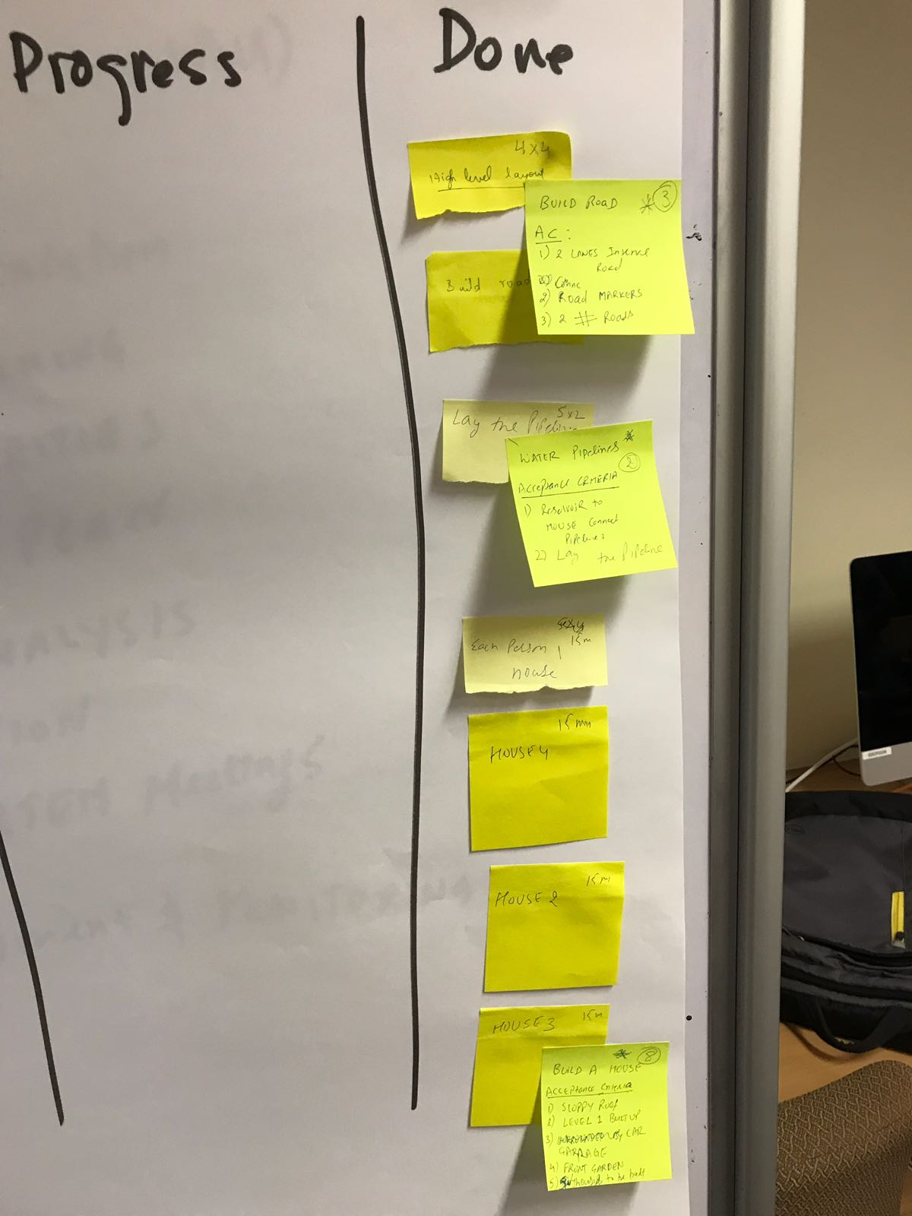

## Sprint Retrospective:

We identified the couple of retrospective points as mentioned below:

1. Team lacks the skillset for Lego building in general
2. Some tasks which were estimated didn’t take that long to complete
3. Team strength is designing

As a result, we put one resource dedicated to the Lego building process, who invested all of his time in learning and building the various blocks as asked by the project.

## Second Sprint Planned:

We put our rest of the items planned in the second sprint. However since we knew that the some tasks were not taking time as planned, we decided to build the add-ons as well for the project which were earlier out of scope of the release. The screenshot shown below explains all the items:

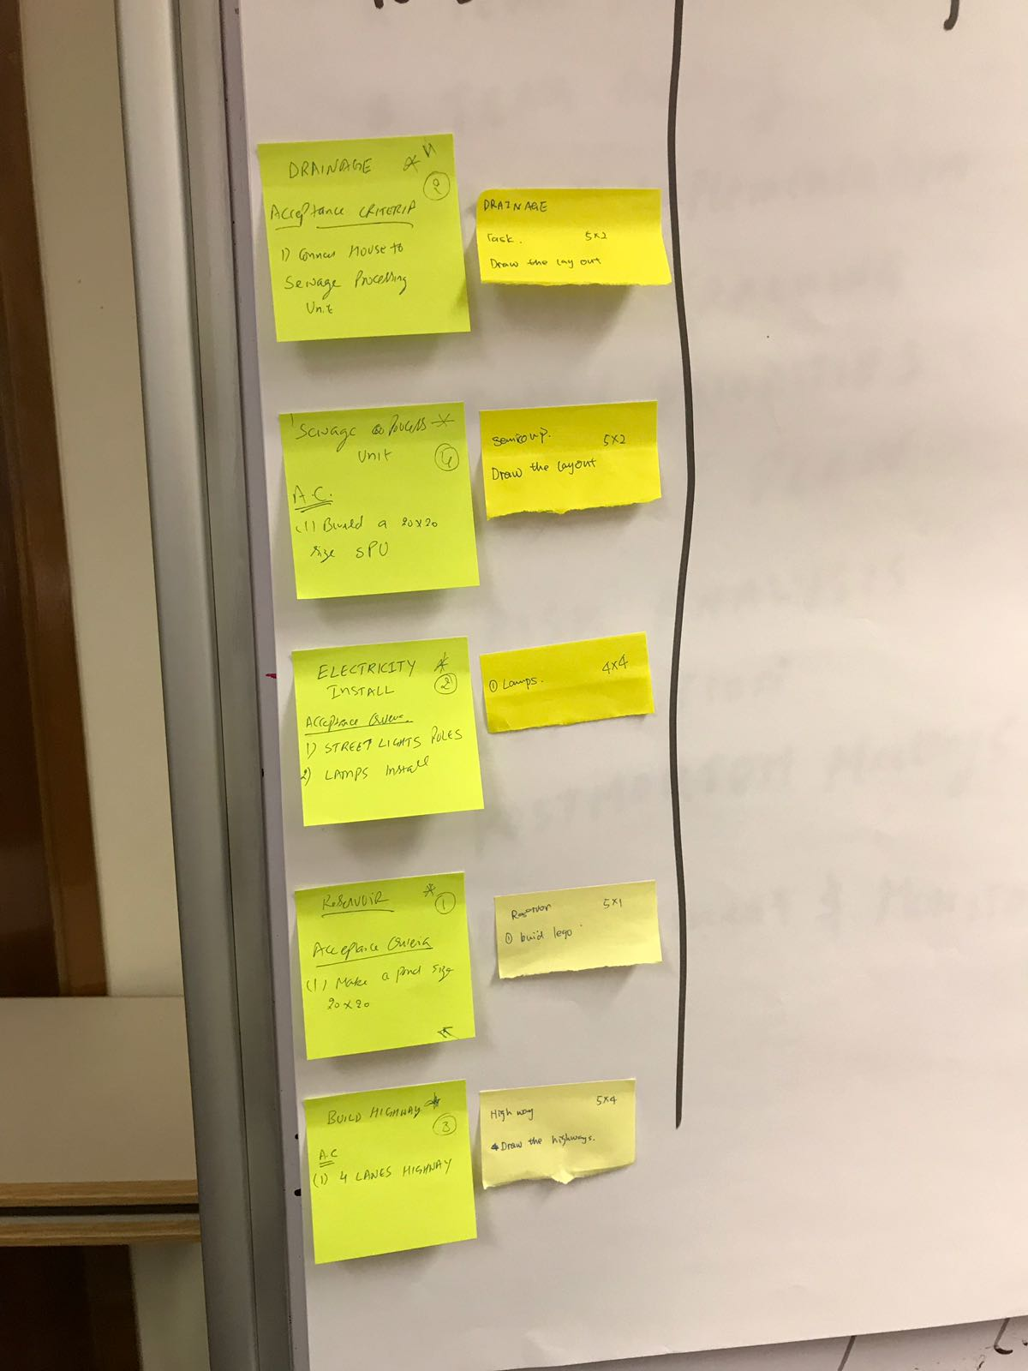

## Second Sprint Execution:

Like first Sprint, we could accomplish the second sprint tasks on time as well.

## second sprint Restrospective:

1. Putting the resource dedicatedly for Lego building helped make things even faster
2. The release burndown/sprint burndown was distorted due to the overestimate of few tasks

## Release burndown/Sprint burndown

The burndown charts are shown as below:

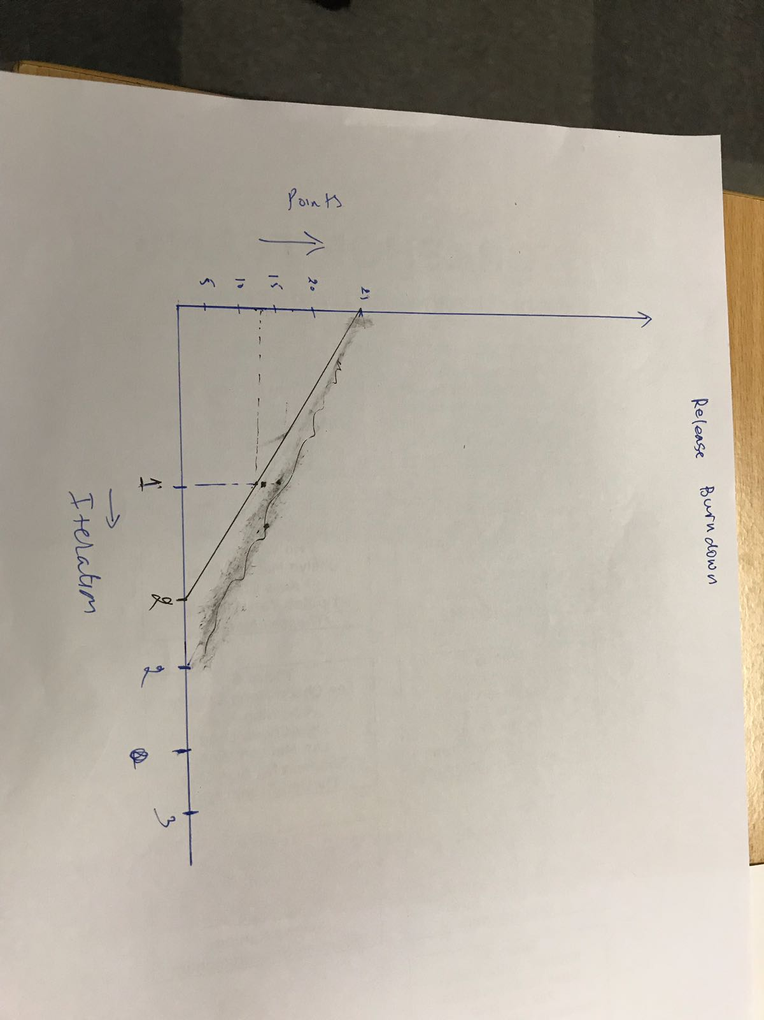

**Release burndown Chart**

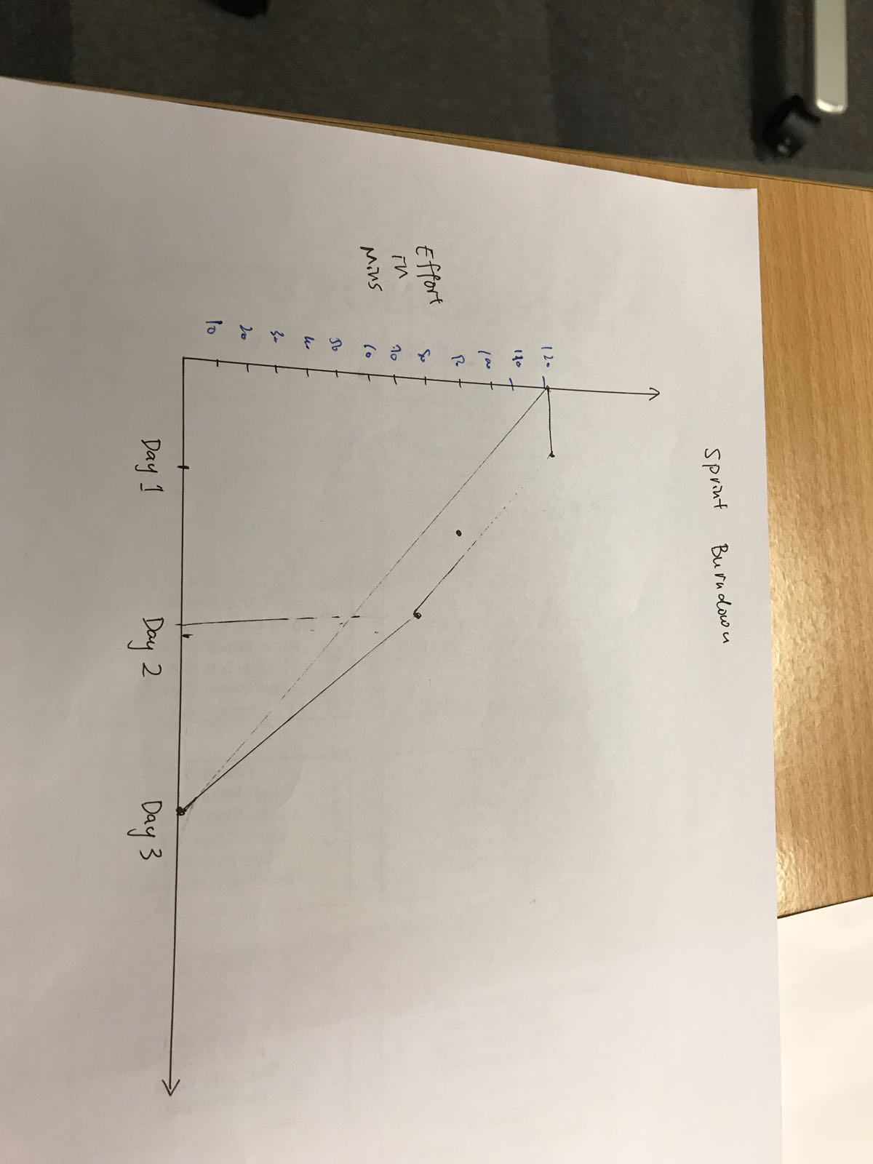

**Sprint 1 burndown**

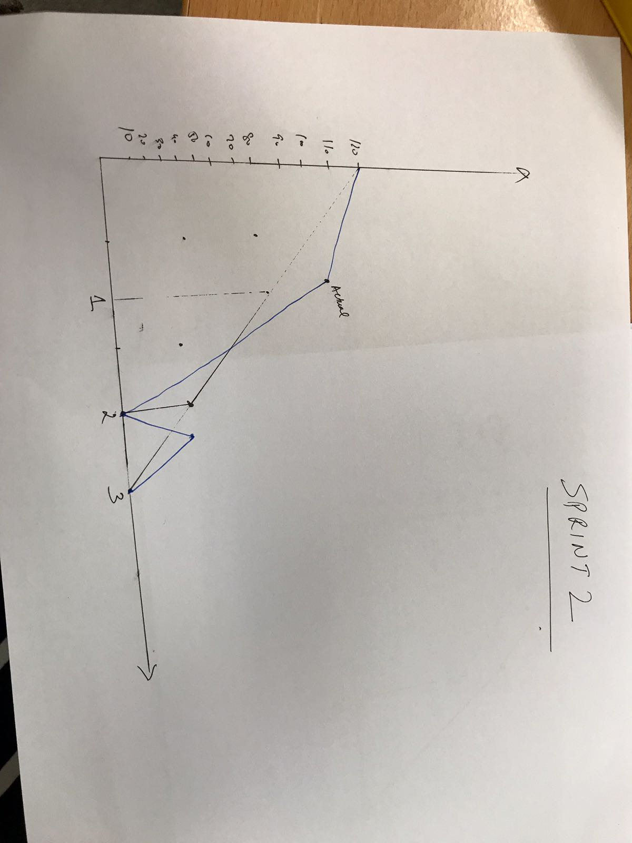

**Sprint 2 burndown**

## final State of Project

Below images shows the initial and final state of Lego City Project:

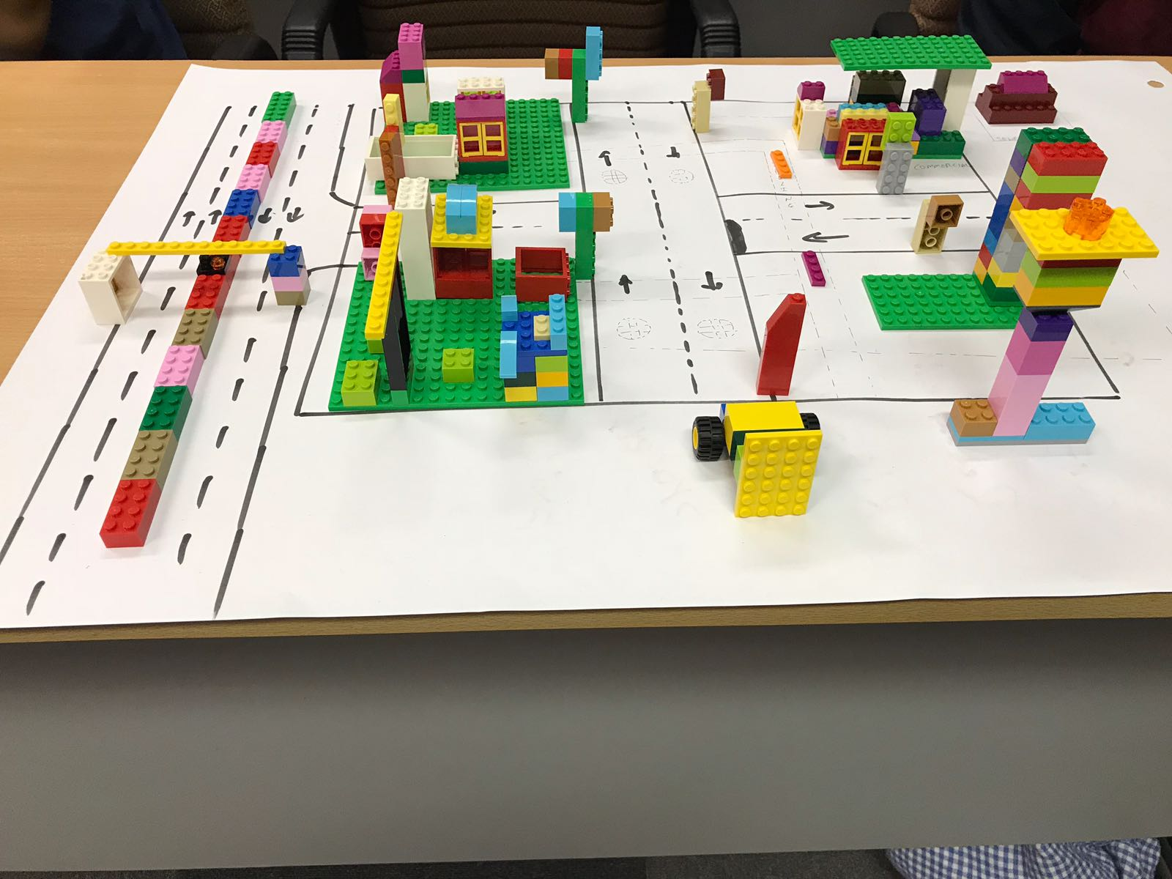 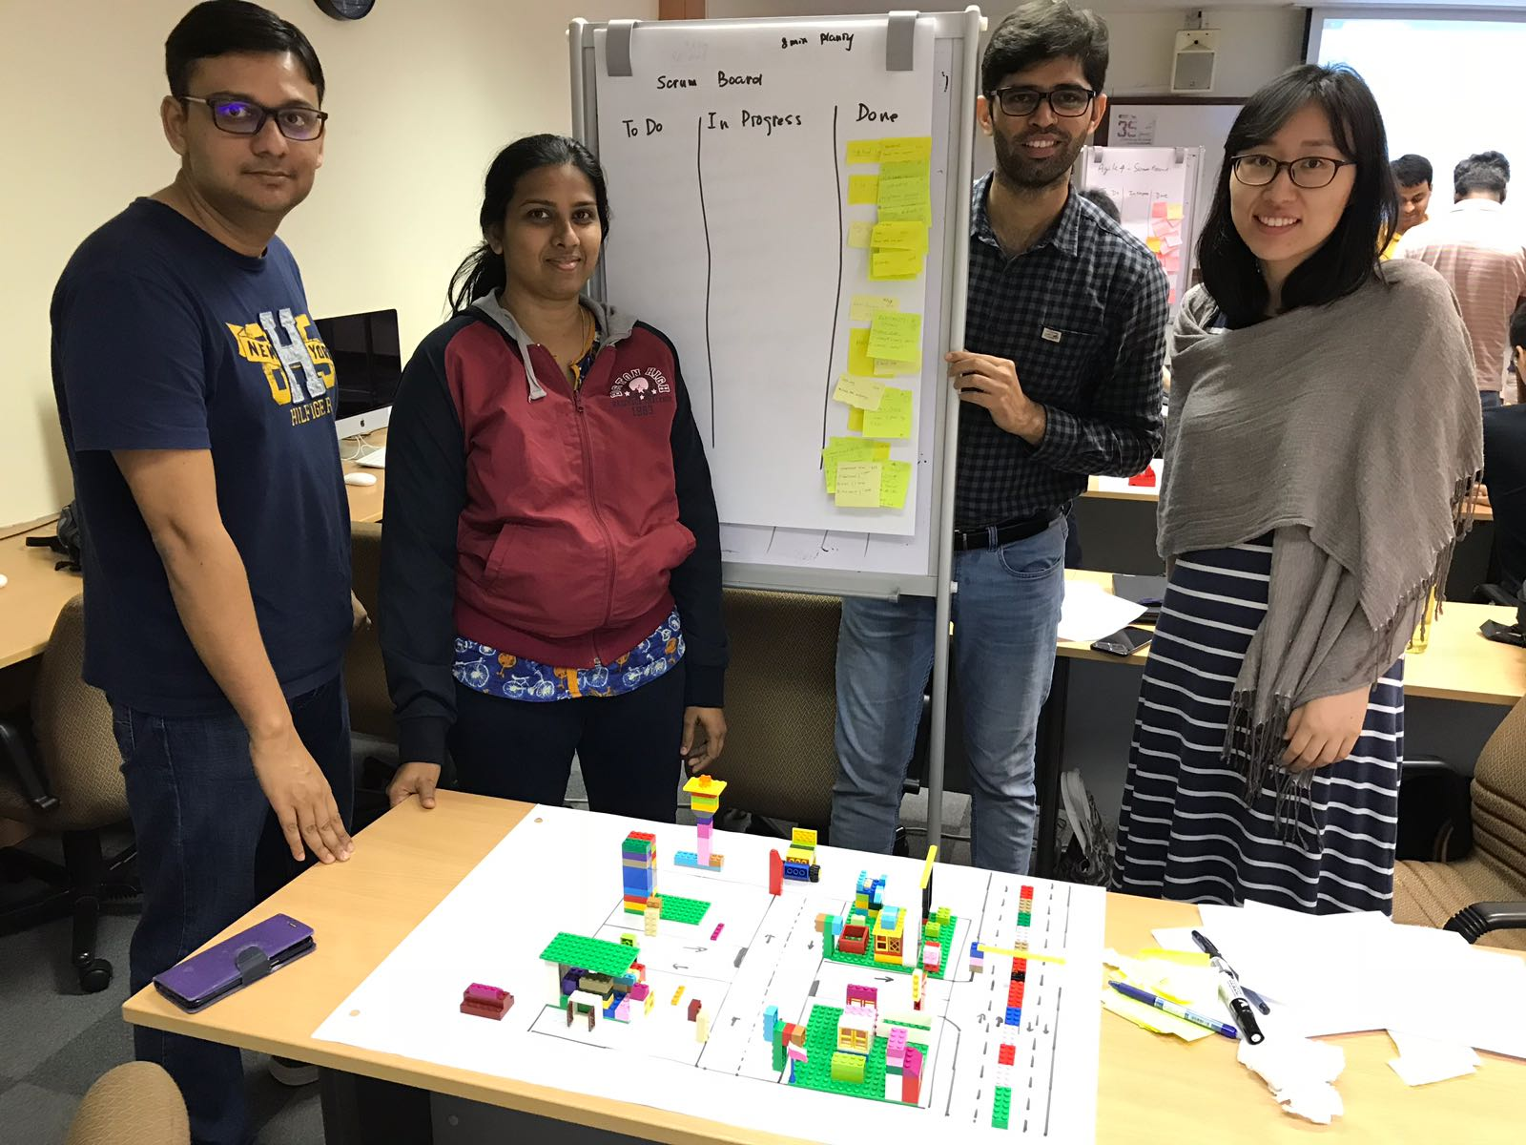

## References

1. Lecture Notes
2. Team brainstorming and innovation